COVID-19 Plan Template
Operating at Alert Level 3
Rev 1.0 | 23 April 2020

Contents
1. Introduction 3
2. Information 3
2.1 Sources of official health and business information 3
3. Key Practical Steps 4
4. Operating at COVID-19 Alert Level 3 4
4.1 Pre-Start-up Activities 5
4.2 General Management Approaches for Operating at Level 3 5
4.3 Access Controls 6
4.4 Transport Controls 7
4.5 Physical Distancing and Hygiene 7
4.6 Contact Tracing 10
5. Stopping the spread of viruses from work to home 11
6. Testing Effectiveness of the Approach 11
Appendices 12
Appendix A: Pre-Start Up Checklist 12
Appendix B: Personal Health Flowchart 14
Appendix C: Use of PPE 15
Appendix D: Cleaning guide 19
Appendix E: Responding to a Suspected Case of Covid-19 22

1. Introduction
Note, in this document, some text is in red italics. This text is for notes or explanations and should be deleted (or updated) in the final plan you produce using the template.

Aon has developed the attached template guidance document for clients looking to operate at COVID-19 Alert Level 3. This can be used together with other sources of information to help you develop a plan to demonstrate how you can safely operate at Level 3.

Being able to operate at level 3 does not necessarily mean that a business will operate at Level 3. This may not be viable for several reasons including:

- Supply chain disruption impacting the business.
- Availability of the workforce.
- Customer or market impacted.

Some of these issues may be able to be worked through and alternatives identified. This process is outside of the scope of this planning document but contact us if you would like support with these issues.

Businesses can also consider a staged restart to give further time to assess the new way of working.

2. Information

2.1 Sources of official health and business information
The following is a non-exhaustive list of information sources.

- Unite against COVID-19 website www.covid19.govt.nz
- Business www.business.govt.nz
- Employment www.employment.govt.nz
- Ministry of Health www.health.govt.nz
- World Health Organisation www.who.int

The WorkSafe website https://worksafe.govt.nz/ contains advice on their expectations for businesses operating at level 3 and a risk management template which can be used together with the guidance in this template plan.

There are also industry documents including the construction sector (construction site focused) protocols https://www.chasnz.org/ as well as manufacturing industry protocols at https://covid19.ema.co.nz/

Further useful sources may be found in the appendices. Information in this document is based upon available information on the 20th April 2020.

3. Key Practical Steps
The key practical steps to consider are summarised below. These are expanded upon in the remainder of the template.

- Undertake risk assessment to identify any risks brought about by COVID-19 and prepare a written safety plan (purpose of this template document). Consider risks relating to restarting your business activity, mental health, any PPE shortage as well as the transmission of COVID-19. Consider whether changes in operation introduces any new risk (e.g. changes in staff levels, shift patterns, physical layout, etc.)
- Communicate with workers the steps being taken to ensure your health and safety at work and to protect the business during this time. Engage with them and their representatives about this. Consider their suggestions or concerns.
- Consider a staged restart, consider partial working from home.
- Have clear processes for contact tracing.
- Consider how to identify and account for vulnerable people. Start a dialogue with ‘at risk’ workers around staying at home/or putting in place additional measures to keep them safe at work and while travelling to/from the workplace.
- Consider risks and controls for all aspects of the working process including arrival at work, normal work operations, leaving work and what to do in an emergency (including a COIVD-19 incident).
- Consider staggering of meal and rest breaks, arrival/departure times, toiler usage, etc.
- Follow specific guidance on distancing and hygiene from government information.
- Have a process for monitoring and review of the plan that is developed.
- Engage regularly with workers who are working from home to ensure they are (and feel) supported.
- If there are issues with PPE supply then identify alternatives (take advice from specialists if necessary) or alternative control measures.

4. Operating at COVID-19 Alert Level 3
Requirements for operating at Level 3 are broken into the following six sections:

- 4.1 Pre-start: Ensuring things are in place for a safe return to operations.
- 4.2 General Management: Key management measures to support safe operation.
- 4.3 Access Controls: Removing or minimising levels of exposure into your or customers sites.
- 4.4 Transport Controls: Removing or minimising levels of exposure related to movement.
- 4.5 Physical distancing and Hygiene: Maintaining physical distancing and hygiene in the workplace.
- 4.6 Contact Tracing: Identification, reporting and contact tracing in the event of a COVID-19 case.

The following supporting information is provided in the appendices:

- A pre-start up checklist (Appendix A)
- Personal Health Flowchart (Appendix B)
- Use of PPE Guide (Appendix C)
- Cleaning Guide (Appendix D)

4.1 Pre-Start-up Activities
Before commencing operations at level 3 a pre-start process should be undertaken this could include:

Site review (site walk) to look for changes to the environment. Check on safety controls. Ensure that these are all in place and operational.
review of the hazard register (risk register) to confirm that changes are still sufficient given changed work environment taking into consideration issues such as impacts on ‘buddy checking’, reduced personnel numbers, altered tasks, altered site movements (people and traffic flow), reduced supervision, altered operating hours, etc. Document and communicate any changes to workers and specifically include COVID-19 as a new hazard on the register.
Development of updated induction material which include requirements for managing the COVID-19 risk (including the contents of this plan).
Providing refresher induction for existing contractors using the new material.
Review Safe Work Method Statements, Standard Operating Procedures, etc., for any additions or alterations for safe operations with COVID-19 restrictions.
Develop registers and forms including contact tracing registers, etc.
Determine needs for PPE (initial and ongoing) and establish supply arrangements.
Determine required work teams and shift structures. Define processes for shift handover, split team working, staggered start and end times and staggered break times.
Determine required process flows and movement of people. Determine potential interaction zones. Establish physical barriers, signage and demarcations to control and limit interactions.
Specifically allow for spacing in areas such as offices, lunchrooms and meeting. Demarcate (or remove) desks, chairs, etc, to allow empty space. Allocate additional space in the building for activities if required.
Provide signage and messages to reinforce requirements.
Communicate requirements to workforce including consideration of pre-start “toolbox” talk(s).
Communication of changed operations (and expectations) to contractors, suppliers, etc.
Communication of changed operations to customers.
Communication of changed operations to stakeholders including insurer (insurance broker), fire service, security company, etc.

For further details particularly on property risk features refer to the checklist in Appendix A.

4.2 General Management Approaches for Operating at Level 3
4.2.1. Management
Stay in contact with all workers including those who may be in isolation or working remotely.
Management and H&S Committee to maintain clear communications channels to all staff on
any pending actions and the transition between levels.
Monitor information sources frequently.
Review plan regularly to ensure actions are appropriate and sensible.
Stay in contact with employees to monitor wellbeing particularly those who are vulnerable or who have vulnerable members of their household.
Actively engage on safety and suggest improvements or highlight any potential unsafe
activities.
Don’t forget your normal health and safety obligations still apply. These Protocols are
in addition to your usual health and safety controls.

4.2.2. Personnel
Management and H&S Committee to maintain clear communications channels to all staff on
any pending actions and the transition between levels.
Operate in a reduced services model where services are scaled back to essential response
services and works where we can maintain the recommended safe physical distancing.
Employees observe reduced work directives from management and operate from home,
where agreed.
Follow government directive of “Workers must work from home if they can”.
Employees to remain contactable as any directive to work from home is still work.
Workplaces must operate safely – keeping one metre between workers, recording who is
working together, limiting interaction between groups of workers, disinfecting surfaces, and
maintaining high hygiene standards

4.3 Access Controls
4.3.1. Site Entry
Limit visitors and contractors to sites as far as possible. Defer non-essential contractor activity or undertake in house.
Induction (remote) for visitors and contractors will cover COVID-19 related requirements including physical distancing and hygiene.
Where periodic contractors or visitors access site then to the extent practical these should be from the same individuals from the same companies.
Consider use of dedicated agreements from contractors so that personnel visiting the site have not visited other sites (outside of your business).
Visitors/contractors shall evidence their own plans for safe operations whilst on client sites.
Site entry procedures shall be complied with every time the site is entered even for re-entry on the same day.
Only employees with no signs of any illness to attend work. Refer to Personal Health Flowchart (Appendix B).
Consider use of temperature monitoring and recording for personnel entering site.
External Doors remain locked and doorbell is used for alerting

4.3.2. External interfaces
One employee nominated to receive deliveries.
Keep the engagement with the couriers / freight forwarders as brief as possible.
Ask for paperwork to be emailed rather than handed over as much as possible:
Use your own pen to sign any slips
If unavoidable, then either wear gloves when handling the item or wash hands before and
after handling any items.
Delivery drivers should remain in their vehicles if the load will allow it and must wash or
clean their hands before unloading goods and materials.

4.4 Transport Controls
4.4.1. Travel by Car
When using a vehicle, the Cleaning Guide (Appendix D) must be followed.
Only travel with one person per vehicle where possible. If you are required to have more
than one person then keep as much distance between people as possible, open the windows
to keep air circulating and passengers to face towards the window to reduce the spread of
germs.
If you need to have multiple people in a vehicle, then where possible, split teams into groups
and stay in those groups when you travel together.
Provide PPE including sanitiser in vehicles.
Provide journey plans. Consider use of vehicle location tracking.

4.4.2. Commuting to Work
Minimise exposure during commute by practicing physical distancing and good hygiene on public transport.

4.4.3. Visiting External Sites
Site inductions required for all sites to be visited.
All sites to be visited to have formal health and safety and public health plan in place.
Requirements on site to be consistent with this plan (or client requirements if more stringent).
Ensure antiseptic / alcohol-based sanitiser is available and used
Company to provide PPE. Gloves, Sanitiser, masks in addition to standard PPE.
Provide cleaning wipes for employees to enable surface wipe down.

4.4.4. Regional Travel
‾‾Only essential inter-regional travel approved by Management to be undertaken.
If appropriate carry essential services documentation.
Provide journey plans.

4.5 Physical Distancing and Hygiene
4.5.1. What is physical distancing?
Physical distancing, sometimes known as “social distancing”, is about keeping a safe distance from
others. Physical distancing means remaining one metre away from other people. This is important to
help protect us from COVID-19, which spreads via droplets from coughing and sneezing. Staying (at least) one metre away from others is an effective measure.

4.5.2. General Working Arrangements
Limit personnel to those who cannot work from home.
Keep team sizes as small as possible.
Consider using split shifts (home shift/workplace shift) such that in the event of a COVID-19 case only a proportion of the workforce is affected.
Consider using of formalised staggered start and departure times to limit congestion at entries, gathering points, lifts and stairwells, etc.
Workplace is to be segregated into zones (or by other methods) as much as possible to keep
different teams physically separated at all times.
Use empty desks as demarcation (one desk empty between each person). Similarly, in meeting rooms, etc., remove chairs to force physical distancing.
Internal doors remain propped open to minimise handling.
Offices shall be accessed only by the person who normally occupies. Maintain interpersonal communications either from the doorway or in communal open spaces.

4.5.3. Entry Points
Monitor entry points to enable physical distancing, consider use of one-way systems with designated entry and exit points/paths.
Where entry systems that require skin contact e.g. door handles, lift pads, etc., are used, Cleaning Guidelines must be followed.
All workers to wash or clean their hands when entering and leaving the site. Facilities to be provided at site entry.
Regularly clean common contact surfaces in reception, office, access control and delivery
areas e.g. Printers, screens, telephone handsets, desks, door handles, lift buttons, particularly during peak flow times.
Any sign in registers should be recorded by one person where possible – do not pass
material around the group and minimise contact with any screens.

4.5.4. Meetings
Only absolutely necessary meeting participants should attend.
Attendees should be a min one metre apart from each other
Rooms should be well ventilated / windows opened to allow fresh air circulation.
Hold meetings in open areas where possible. Consider ‘walking’ meetings.
Meetings (including inductions) are to be held through teleconferencing or videoconferencing where possible.

4.5.5. Avoiding Close Working
Risk assessments and method statements must be updated to include COVID-19 control
measures.
Plan all work to minimise contact between workers.
If it is not possible or safe for workers to distance themselves by one metre for a work
activity the following steps must be satisfied:
o Are the works essential and do they need to be carried out now?
  - If not, the works should not be carried out.
  - If they do need to be carried out additional control measures must be in
place.
o Additional controls could include:
  - Wearing disposable overalls.
  - Wearing of PPE (face masks).
  - Wearing of powered ventilation.
  - Short duration works.
  - Reducing number of operatives.
Re-usable PPE should be thoroughly cleaned after use and not shared between workers.
Single use PPE should be disposed of so that it cannot be reused.

4.5.6. Toilet Facilities
Wash hands before and after using the facilities.
Enhance the cleaning regimes for toilet facilities particularly door handles, locks, toilet flush
and sanitary bins.
Provide suitable and sufficient rubbish bins for hand towels with regular removal and
disposal.

4.5.7. Eating Arrangements
Dedicated eating areas should be used to reduce risk of contamination. Eating at desks discouraged.
Break times should be staggered to reduce congestion.
Hand cleaning facilities or hand sanitiser should be available at the entrance of any room
where people eat and should be used by workers when entering and leaving the area.
Use of cooking facilities shall be limited. No use of equipment where there is direct contact between food and surfaces such as grill plates, toaster machines, etc.
Contact between food items to be minimised no communal storage of food.
Workers should sit 2 metres apart from each other whilst eating and avoid all contact.
Shared crockery, eating utensils, cups etc. shall be cleaned in the dishwasher
Tables should be cleaned between each use.
All rubbish should be put straight in the bin and not left for someone else to clear up.
All areas used for eating must be thoroughly cleaned regularly through the day, including
chairs, door handles.
Coffee machines and water fountains use shall be limited.
Consider numbers on site for site facilities as physical distancing may require additional
space/facilities or careful management of break timing.

4.5.8. Smoking
Smokers/vapers must use designated areas or do so off-site and butts are to be placed in the
designated receptacle. Hands must be washed before and after smoking.
Stand so that smoke or vapor produced is not going into another person’s breathing zone.

4.5.9. General Hygiene
Each worker must sanitise their hands with hand sanitiser or soap and running water before entry to work, use warm water if available.
Any personal items brought to work must be segregated (kept separate from other workers
items).
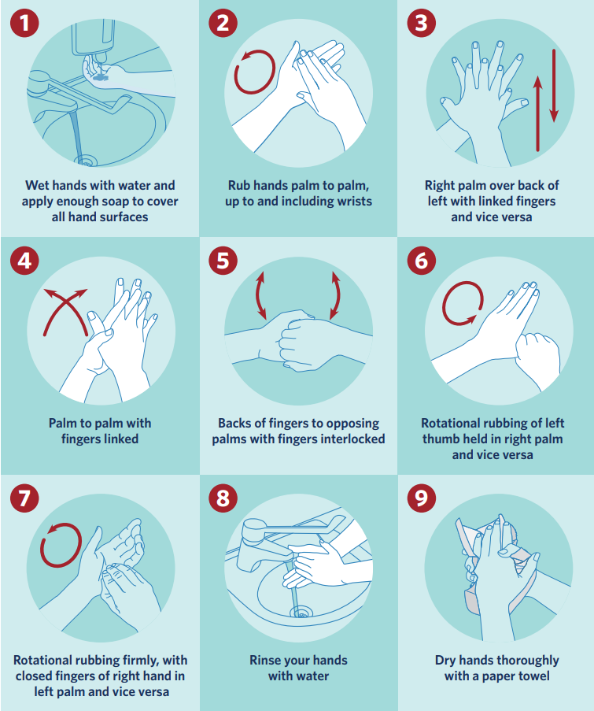
Individual PPE for workers must be kept separate from other workers PPE and cleaned correctly as per the Cleaning Guide.
All eating and drinking utensils to be cleaned by the user. Have paper towels accessible to dry.
Surfaces should be kept clear to enable cleaning. (i.e. put papers and folders away).

4.5.10. Hand Washing
Provide additional hand washing facilities to the usual welfare facilities on large, spread out sites or significant numbers of personnel on site.
Ensure soap and fresh water is readily available and kept topped up at all times.
Provide hand sanitiser where hand washing facilities are unavailable.
Regularly clean the hand washing facilities and check soap and sanitiser levels.
Extra supplies of soap, hand sanitiser and paper towels shall be maintained and securely stored.
Remove wrist and hand jewellery (apart from wedding band).

4.6 Contact Tracing
All personnel need to be able to be contact traced.
o Simple in/out to be used for employees. Employee to verify active on arrival.
o Register of all contractors and visitors entering and departing premises. This will only be
couriers and freight personnel. Register to include name, company, email, phone number.
Keep a record of who is in each team every day.
Keep a record of car journeys and any external site visits each day. Record date, time, personnel, vehicle ID, journey details, site(s) visited, contact(s) at visited sites.
Keep a record of air travel journeys and any external site visits each day. Record date, time, personnel, flight numbers, seat numbers, journey details, site(s) visited, contact(s) at visited sites.
Consider use of individual tracking (GPS enabled devices) and/or vehicle tracking to support contact tracing.

5. Stopping the spread of viruses from work to home
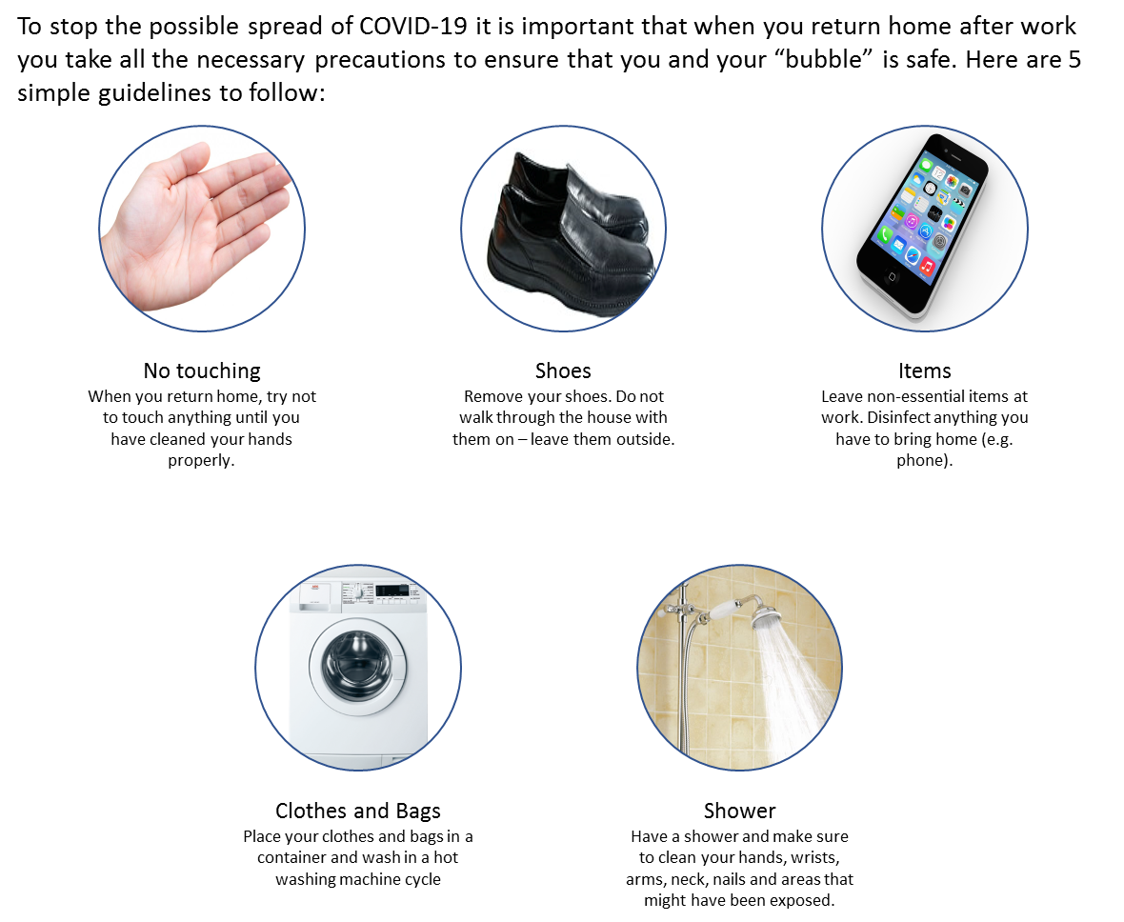

6. Testing Effectiveness of the Approach
There are several ways that the effectiveness of the approach can be tested these include:

Implement leading and lagging performance indicators for the measures introduced.
Undertake internal audits (including unannounced checks) to review effectiveness including observation of physical distancing and hygiene practices.
Commission external audits to review performance against plan as well as good practice benchmarks.
Periodic review for improvement opportunities.

Appendices

Appendix A: Pre-Start Up Checklist

 | Y | N | Comment / Required Action
Communications and Planning
Communication of plan to workforce
Develop COVID-19 induction materials
Amend SOP materials for COVID-19
Develop COVID-19 specific risk management materials
Develop COVID-19 lead and lag performance indicators
Develop COVID-19 contact tracing registers (sign in register, etc)
Source initial and ongoing PPE requirements
Make physical changes to workplace – barriers, zoning, changing eating areas, entry points, etc.
Define and document any team/shift compositions
Authorities
Are local authorities, fire brigade and police informed about the site re-opening?
Are any required building compliance inspection (Building Warrant of Fitness items) arranged?
Are any required certified plant and machinery inspections (boilers, cranes, etc) arranged?
Insurances
Has your (company) insurance contact or your Aon contact been informed on the plans of the site re-opening?
Stakeholders
Have stakeholders including (as applicable) the property landlord, sub-tenants, etc., been informed on the plans of the site re-opening?
Pre-Startup Inspections/Checks
Inspect site condition for any indication of damage. Arrange for any repair as necessary.
Confirm security systems are all operational.
Confirm fire systems are all operational. Confirm system pressures on sprinklers, confirm no leakage.
Check equipment for any signs of leaks and seeps including transformers, oil systems, etc.
Security
Reinstate normal security practices and procedures.
Inform the alarm monitoring company/security firm of the site status?
Are all access cards of employees who need access to the location reactivated?
Is the exterior lighting switched operating?
Are all gates, doors and all windows in good condition and operable?
Are ladders, external stairways and fire escapes allowing access to roof clear and accessible?
Fire safety
Are the automatic sprinkler systems, other automatic fire extinguishing systems, fire detection system and fire doors in service?
Are diesel tanks for the (sprinkler) water supply pump(s) and emergency generators full?
Are fire doors closed? (Unless on automatic hold open device in which case is function of release rested?)
Have you checked whether sprinkler valves are secured in fully open position? Is the sprinkler valve house/pump house secure?
Have you checked whether underground yard hydrants are not covered / blocked by outdoor storage or parked trucks and that hydrant main section valves are in open position?
Have you checked that the water supplies for the fire brigade remain fully operational and accessible?
Have you updated the response procedures and escalation processes for the alarm monitoring company for any privately monitored fire alarms (e.g. security company monitored smoke alarms)?
Are all hand fire extinguishers and hose reels good visible and freely accessible?
Are unneeded combustible materials removed from the exterior area, e.g. idle pallets, waste and other disused combustible materials?
Are all outdoor metal (waste) containers closed and locked or at safe distance from main buildings? These should be located at least 10 m from main buildings.
Is any temporary internal storage (for security) removed?
Are flammable liquid tanks and pipe work recommissioned?
Are combustible dusts cleaned down to the extent practical?
Are gas supplies (bulk LPG or mains) checked and secured?
Utilities and other (small) appliances
Are emergency generators standby and have they been tested recently?
Are temperatures of temperature-controlled rooms, like cold stores in correct range?
Are all building heaters free of combustible materials (minimum 2m)?
Have you reconnected and checked all battery charging systems?
If possible carry out thermographic checks on electrical boards.
Has deenergised equipment been checked and reenergised?
For areas with a freezing risk, is there any indication of freezing?
Are all kitchen cooking appliances, like toasters, deep fat fryers, etc. returned to service?

Appendix B: Personal Health Flowchart

Appendix C: Use of PPE
General
Use of PPE will need to be consistent with the activity being undertaken.
PPE for hygiene (typically masks and gloves) will be associated with activities where there is an increased risk of COVID-19 exposure for example cleaning activities, working in close physical contact, or in other situations where the need for hygiene PPE has been identified.
In workplaces where traditional PPE such as safety glasses, hearing protection, safety boots, hard hats, etc., would be required these should still be used. There may be tasks where both hygiene PPE and traditional PPE would be required.
Traditional PPE shall be cleaned (if re-useable), not shared, and otherwise managed to reduce the risk of COVID-19 contamination.

The NZ Ministry of Health Guidelines for Workplaces are summarised below. For current advice, check www.health.govt.nz/our-work/diseases-and-conditions/covid-19-novel-coronavirus/covid-19-novel-coronavirus-health-advice-general-public/covid-19-face-mask-and-hygiene-advice
- Workplaces where people can maintain more than 1 metre contact distance from people with potential COVID-19 symptoms – facemasks and gloves are not recommended.
Examples of these workplaces include, but not limited to education facilities, pharmacies, retail outlets.
- Workers where people can maintain more than 1 metre contact distance from people with potential COVID-19 symptoms but work in an environment where they are touching surfaces or items touched by others – they may consider wearing gloves. Facemasks are not recommended. Regular hand hygiene must continue.
Examples of these workplaces include, but not limited to supermarkets, services stations
- People who, due to the nature of their job, may be unable to maintain more than 1 metre contact distance from people with potential COVID-19 symptoms – facemasks and gloves are recommended when this contact is likely to occur. Examples of these workplaces include but not limited to police, prison staff, customs staff.
These recommendations are a guide only and workplace settings should consider their ability to maintain the 1 metre rule. In general, surgical/medical masks prevent the dispersal of droplets by an infected patient and the inhalation of droplets if within 1 metre of a coughing individual.

Hand hygiene and cough / sneeze etiquette (maintain distance, cover coughs and sneezes with disposable tissues and wash hands) will have a bigger impact.

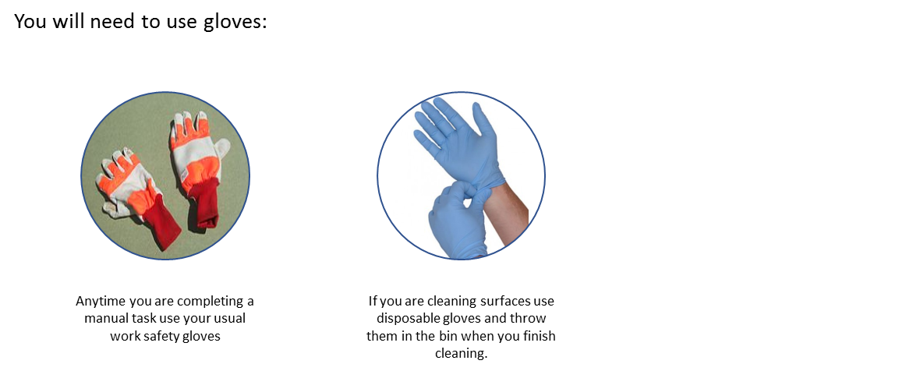

Removing gloves to minimise cross contamination.
1. Pinch and hold the outside of the glove near the wrist area.
2. Peel downwards, away from the wrist, turning the glove inside out.
3. Pull the glove away until it is removed from the hand and hold the inside-out glove with the
gloved hand.
4. With your un-gloved hand, slide your finger/s under the wrist of the remaining glove, taking
care not to touch the outside of the glove.
5. Again, peel downwards, away from the wrist, turning the glove inside out.
6. Continue to pull the glove down and over the inside-out glove being held in your gloved
hand.
7. This will ensure that both gloves are inside out, one glove enveloped inside the other, with
no contaminant on the bare hands.

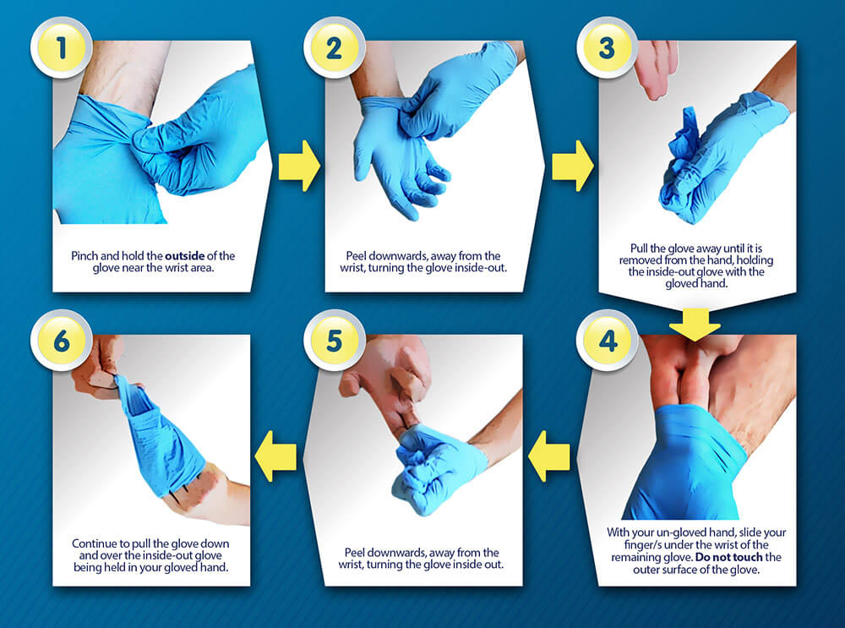

DON’T touch environmental surfaces – e.g.: door handles, a keyboard, a computer mouse –
with contaminated gloves
DON’T touch your face or adjust PPE with contaminated gloves
DON’T remove one glove, and then pull the other glove off by the fingertips
DON’T reuse disposable gloves once they have been removed
DO safely remove excess liquid beforehand
DO change gloves when heavily soiled or if torn
DO dispose of used gloves appropriately, in accordance with your company policy
DO remove (and dispose of) your gloves and wash your hands prior to eating, drinking or smoking/vaping.
DO practice good hand hygiene and good sneeze and cough hygiene whilst wearing gloves.

Use of Masks
Follow the mask fitting and removal procedures provided for the specific mask you are using. As a general process the following steps are provided:
- Wash your hands first.
- Typical disposable masks have a metal clip this should be at the top (nose) of the mask.
- Take care not to touch the inside of the mask, cup the outside and place it onto your face.
- Attach the mask by pulling the bands over the ears.
- Stretch down the front of the mask so it covers your chin.
- Adjust the metal clip on your nose to give a secure fit.
- To remove the mask, pull the elastic bands away from your ears.
- Dispose of the mask in a closed bin.
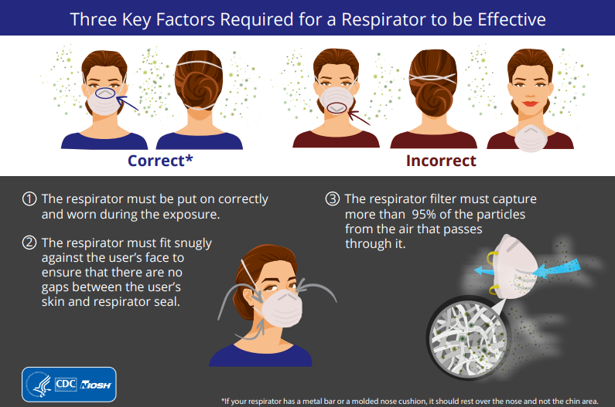

DO Ensure the mask is not damaged (no rips or tears or holes).
DO Ensure the mask is the correct size for a good fit.
DO If possible remove facial hair to ensure a tight fit.

Appendix D: Cleaning guide
Consider your work environment and what is frequently used and touched by workers, customers
and others. The virus can be spread from person to person or by touching unclean equipment or
surfaces. To stop the spread, focus efforts on cleaning areas where the virus is more likely to
spread, such as the kitchen and toilet.

Physical distancing should also be practiced when cleaning offices and jobsites. Refer to the
Physical Distancing and Hygiene section for more information.

Schedule regular cleaning.
Use a suitable cleaning product.
Use disposable cloths, if available.
Always wear disposable gloves when cleaning. When finished, place used gloves in a rubbish
bin.
Wear disposable gloves while handling soiled items.
Wash hands immediately after removing gloves or after handling these items.

Disinfecting cleaning aids
Cleaning aids, such as cloths or mops, must be germ-free or they’ll spread germs to other
surfaces. Here are some general cleaning tips to help prevent the spread of germs:
Cloths and sponges
o Use disposable cloths or paper towels when possible.
o Reusable cloths should be disinfected or washed after each use.
Washing-up brushes
o Wash brushes in a dishwasher regularly or clean with detergent and warm water
after each use.
Mops and buckets
o Use two buckets for mopping – one for detergent and the other for rinsing.
o Mops and buckets should be cleaned and dried after each use.

Key cleaning tips
All offices and jobsites should implement additional cleaning measures of common areas as
recommended by the Ministry of Health and to help minimise the spread of COVID-19.
Regular cleaning of the workplace environment will minimise the spread of infection by reducing
workers’ contact with contaminated surfaces.

Clean surfaces with a suitable cleaner and/or disinfectant and follow the manufacturer’s
instructions for use. When choosing a suitable cleaning product, consider what the product is
effective against and the length of time the product needs to be left on a surface to clean it
properly.

Where possible, use disposable cloths or paper towels to clean surfaces.
Reusable cloths should be disinfected and then dried after use, as bacteria and viruses can still
survive on damp cloths. Common internal touch points may include:

- Coffee machines and/or water fountains.
- Common pens for sign in sheets.
- Doors/door handles - look at all reasonable opportunities to remove them.
- High-touch public surfaces such as stairwell handrails, door handles, table tops, lift buttons, microwaves and other kitchen surfaces.
- Screens and tables should be wiped after use, including iPads, photocopiers, digital check-in scanners and desktop stations.
- Clean floors with disinfectant or bleach solution, starting from one end of the premises to another (from the exit inwards).
- Wash items such as towels, tea towels and other fabrics and dry thoroughly.

Site cleaning
Before leaving the office or site at the end of the working day or end of each shift, wipe down
any tables/surfaces with soapy water or cleaning agents where possible.

All waste and disposable PPE must be securely disposed of.
All door handles, railings and personal workstation areas are wiped down with a
disinfectant, such as disinfectant wipes.
Individuals are responsible for cleaning their workstation area with disinfectant wipes.
Clean all ‘high-touch’ surfaces such as desks, counters, table tops, doorknobs, bathroom
fixtures, toilets, light switches, printers, phones, and keyboards every day with antiseptic wipes or disinfectant, including bleach solutions.

Cleaning bathrooms, toilets and showers
Clean toilets with a separate set of cleaning equipment (disposable cleaning cloths, mops,
etc).
Keep the U-bend and toilet bowl clean by flushing after each use.
Limescale should be regularly removed using a descaling product.
Keep the toilet seat, handle and rim clean by using a disinfectant.
Clean sinks frequently, if they’re used regularly.

Cleaning Tools and Equipment
Clean tools and equipment before and after each day’s work with a disinfectant,
concentrating on points of contact such as handles, keyboards, mice, screens.
Wash your hands after handling tools and equipment to prevent the spread of germs.
If possible, don’t share tools or equipment. If sharing cannot be prevented, take precautions and follow the hand washing guide before and after each use.

Cleaning vehicles
Maintain the cleanliness of the vehicle assigned to you.
Don’t share vehicles if possible, if you need to use a shared vehicle then wipe down the
common touched areas of the vehicle after each use (steering wheel, handbrake, gear stick,
dashboard, handles, etc) and wash hands before and after using the vehicle.
Wipe down the inside and common touched areas of the vehicle before and after each day.

Cleaning PPE
Work clothes to be placed in washing machines and clean reusable PPE.
Read and follow directions on the labels of laundry or clothing and detergent. In general,
wash and dry laundry and clothing with the warmest temperatures recommended on the
label.
When handling soiled laundry wash your hands afterwards. All clothes and towels should be
washed with a laundry product to prevent germs from spreading. Don’t leave laundry in the
washing machine – any remaining germs can multiply rapidly.

Specialist Clean
If a worker is unwell and removed from site, a specialist clean will be completed in the area/
areas identified where the worker was working and has accessed. These areas are to be isolated
until a specialist clean has taken place.

All equipment and vehicles used must be cleaned down and disinfected, concentrating on points
of contact such as handles, steering wheels etc.

Appendix E: Responding to a Suspected Case of Covid-19
If the suspected case is at work
Isolate: Isolate the person from others and provide a disposable surgical mask to wear (if available).
Inform: Call Healthline (0800 358 5453). Follow the advice of health officials.
Transport: Ensure the person has transport to their home or a medical facility as required.
Clean: Clean the area where the person was working and all places they may have been. This may mean evacuating these areas. Use PPE (disposable gloves, masks) when cleaning.
Identify: Identify who at the workplace had close contact with the person in the 24-hour period before they started showing symptoms. Send these people home to isolate. Allow employees to raise concerns.
Clean: Clean the areas where the close contact people were working and all common areas they may have been. This may mean evacuating these areas. Use PPE (disposable gloves, masks) when cleaning.
Review: Review risk management controls related to COVID-19 and review whether work may need to change. Keep employees up to date with what is happening.

If the suspected case is not at work when diagnosed
Inform: Call Healthline (0800 358 5453). Follow the advice of health officials.
Identify: Identify who at the workplace had close contact with the person in the 24-hour period before they started showing symptoms. Send these people home to isolate. Allow employees to raise concerns.
Clean: Clean the areas where the close contact people were working and all common areas they may have been. This may mean evacuating these areas. Use PPE (disposable gloves, masks) when cleaning.
Review: Review risk management controls related to COVID-19 and review whether work may need to change. Keep employees up to date with what is happening.

For further questions, information or comments or suggestions for improvements to document, please contact Neil Gravestock or Chris Standing

Stay safe and healthy!

Disclaimer:
It is acknowledged that this report is based upon information that has been provided by persons other than Aon Risk Solutions, Aon Limited and/or the producer (collectively "Aon") of this report. Aon makes no representation or warranty in relation to the accuracy, currency or completeness of factual information contained in it.
This report is not intended to identify all hazards that may exist, nor is it intended to be an exhaustive review of all possibilities or eventualities. The recommendations for risk improvement contained in this report are purely advisory and the decision and responsibility for implementation rests with the recipient’s management.
This report does not guarantee, assure or warrant in any way that the recipient is in compliance with any laws, statutes, regulations or directives, or that compliance with its recommendations will eliminate all hazards or accidents.
To the extent permitted by law, it is a condition of delivery of this document (whether under contract or otherwise) that Aon shall not be held liable for any loss or damage (including any special, indirect or consequential damages, loss of profit or loss of revenue) including any arising out of or in connection with the data, calculations or opinions expressed herein.

